Please try the questions by yourself and then you can verify the answers from the solutions file.

You are required to run the InitialScript.SQL first to create a table named SALESORDERVALUES and insert 830 rows into the table

Please write the following command to check the output

SELECT * FROM SALESORDERVALUES

This is the screenshot of the output

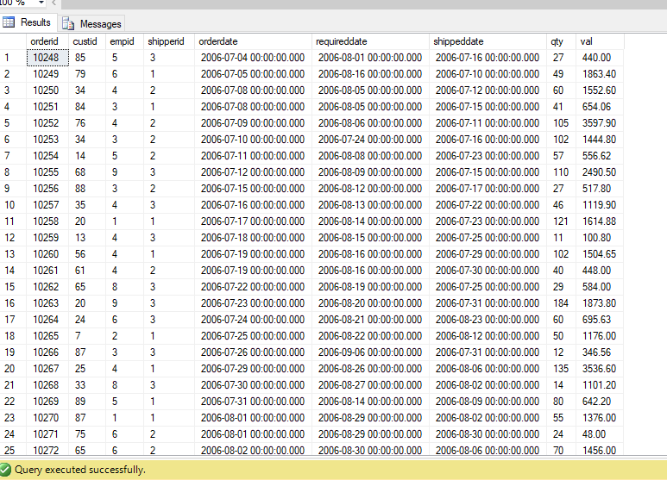

Question 1

Write a SELECT statement to retrieve the orderid, orderdate, and val columns as well as a calculated column named rowno from the table SalesOrderValues. Use the ROW_NUMBER function to return rowno. Order the row numbers by the orderdate column.

This is the screenshot of the output

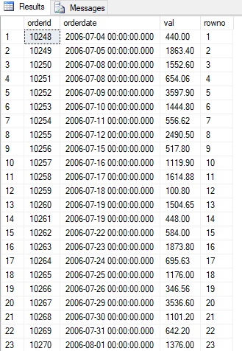

Question 2

Copy the previous T-SQL statement and modify it by including an additional column named rankno. To create rankno, use the RANK function, with the rank order based on the orderdate column.

This is the screenshot of the output

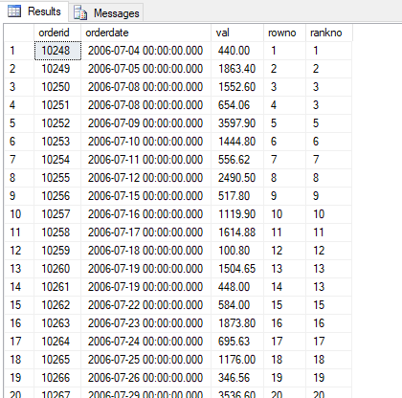

Question 3

Write a SELECT statement to retrieve the orderid, orderdate, custid, and val columns as well as a calculated column named orderrankno from the SalesOrderValues. The orderrankno column should display the rank per each customer independently, based on val ordering in descending order.

This is the screenshot of the output

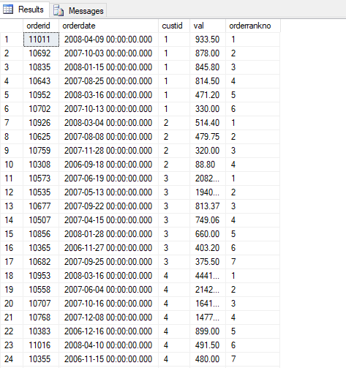

Question 4

Write a SELECT statement to retrieve the custid and val columns from the SalesOrderValues. Add two calculated columns:
orderyear as a year of the orderdate column
orderrankno as a rank number, partitioned by the customer and order year, and ordered by the order value in descending order.

This is the screenshot of the output

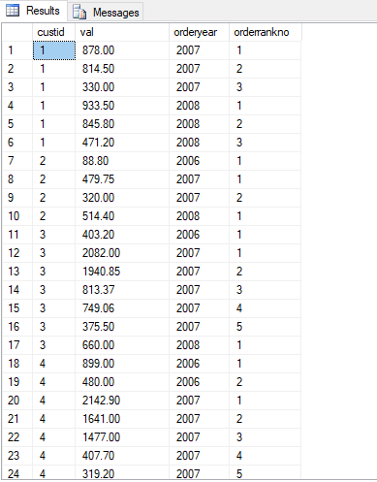

Question 5

Copy the previous query and modify it to filter only orders with the first two ranks based on the orderrankno column.

This is the screenshot of the output

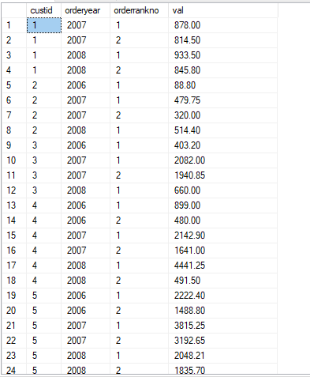

Question 6

Write a SELECT statement to return the orderid, orderdate, and val columns for the current row and the val column from the previous row as prevval. Add a calculated column named diffprev to show the difference between the current val and previous val.

This is the screenshot of the output

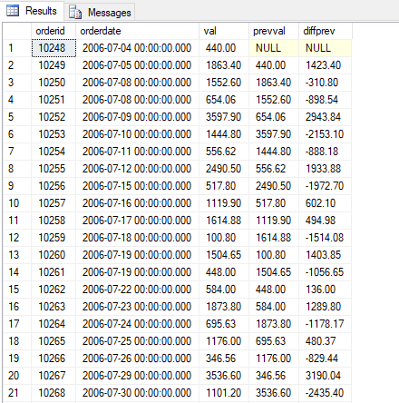

Question 7

Write a SELECT statement to retrieve the custid, orderid, orderdate, and val columns from the SalesOrderValues table.
Add a calculated column named percoftotalcust that contains a percentage value of each order sales amount compared to
the total sales amount for that customer.

This is the screenshot of the output

